Infographic:

<https://medimix7.wordpress.com/2023/09/02/my-infographic/>

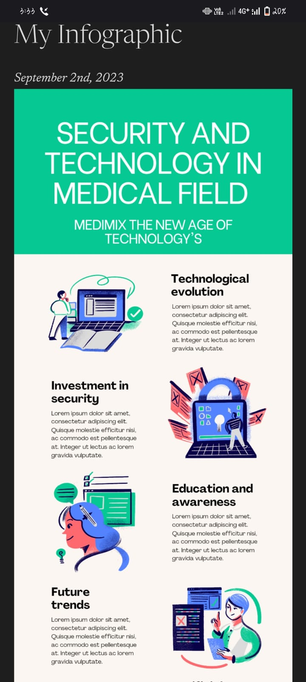

Newsletter:

<https://medimix7.wordpress.com/2023/09/02/email-letter/>

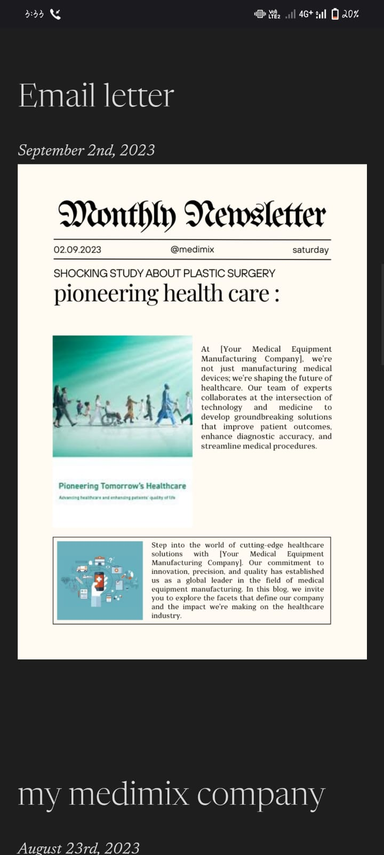

Blog:

<https://medimix7.wordpress.com/2023/08/23/my-medimix-company/>

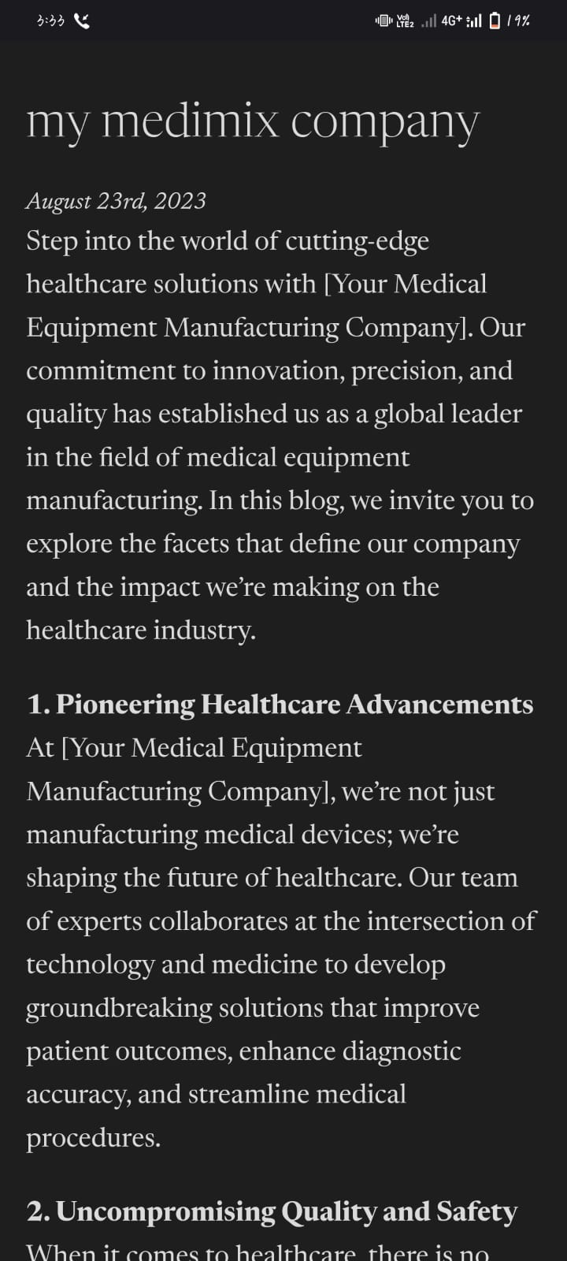

Facebook page:

<https://www.facebook.com/profile.php?id=61550746852395&mibextid=ZbWKwL>

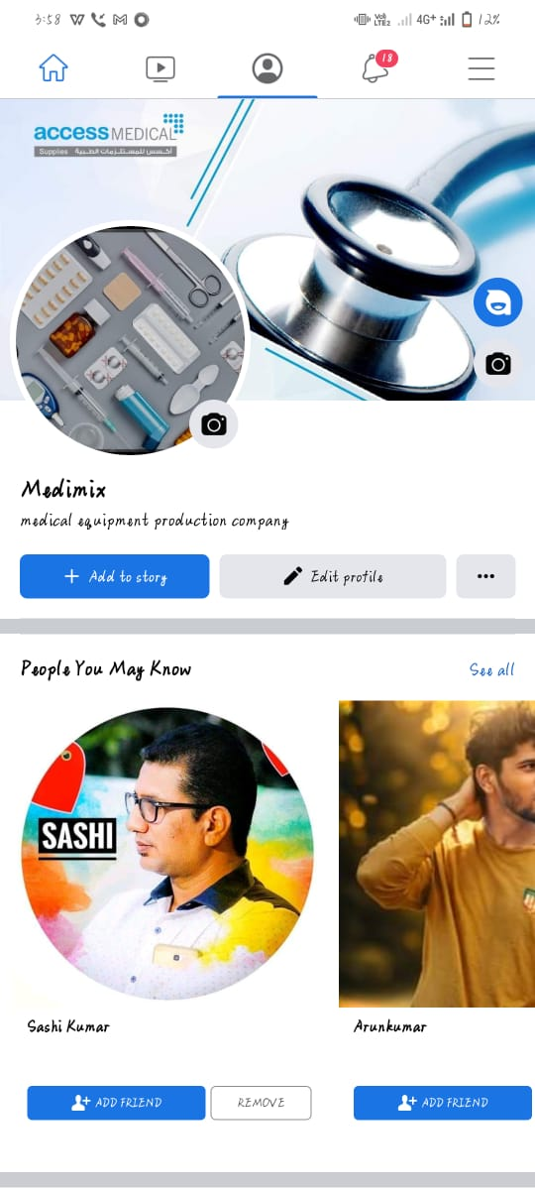

Facebook post:

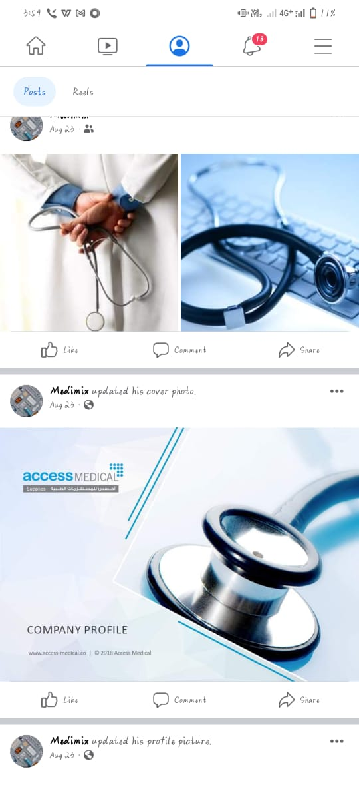

Linkedin:

<https://www.linkedin.com/in/kiran-r-b6b877288>

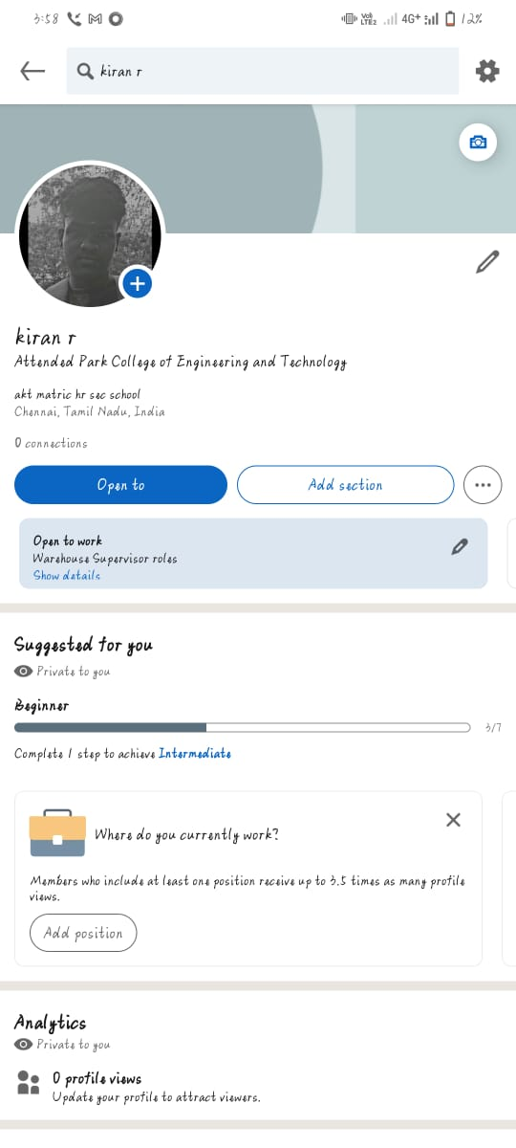

Analytics:

